ST10436137

Dario Hendrickse

INSY7213

SUMMATIVE PROJECT

Table of Contents

Question 1 3

Database and Tables Existing in Connection 3

Table Data and Constraints 4

Volunteer 4

Donor 5

Bike 6

Donation 7

Question 2 8

SQL Code 8

Screenshot of Code 8

Screenshot of Successful Output 8

Question 3 9

SQL Code 9

Screenshot of SQL Code 10

Screenshot of Successful Output 11

Question 4 12

SQL Code 12

Screenshot of SQL Code 13

Screenshot of Successful Output 13

Reference for Justification 13

Question 5 14

SQL Code 14

Screenshot of SQL Code 16

Screenshot of Successful Output 16

Question 6 17

SQL Code 17

Screenshot of SQL Code 20

Screenshot of Successful Output 21

Question 7 22

SQL Code 22

Screenshot of SQL Code 24

Screenshot of Successful Output 25

Question 8 26

SQL Code 26

Screenshot of SQL Code 26

Screenshot of Successful Output 27

Question 9 28

Q9.1: Donation Delete Trigger 28

SQL Code 28

Screenshot of Successful Output and Trigger Occurring 29

Q9.2: Bike Validation Trigger 29

SQL Code 29

Screenshot of Successful Output and Trigger Occurring 30

Question 10 31

Introduction 31

Confidentiality 31

Role-Based Access Control 31

Data Encryption 31

Integrity 32

Database Constraints 32

Audit Trails 32

Conclusion 32

References 34

# Question 1

## Database and Tables Existing in Connection

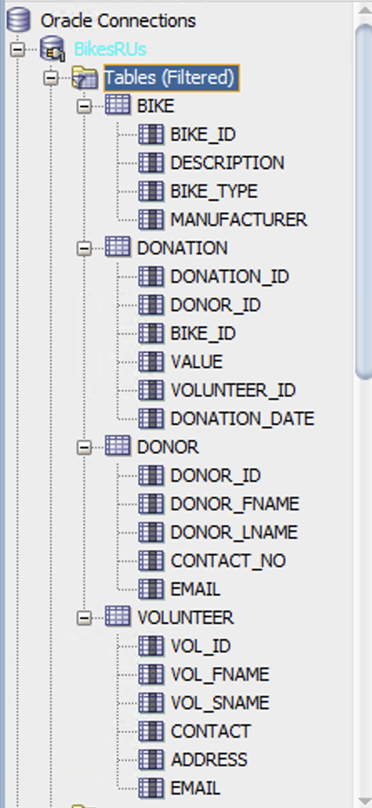

## Table Data and Constraints

### Volunteer

Data:

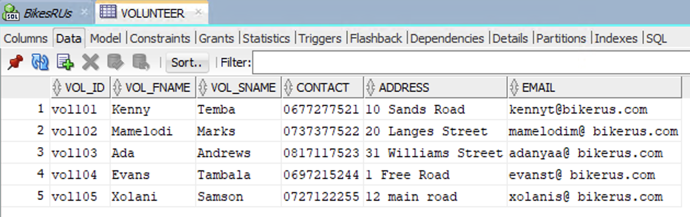

Constraints:

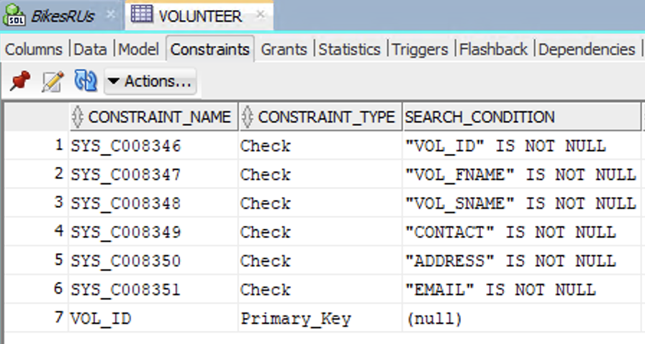

### Donor

Data:

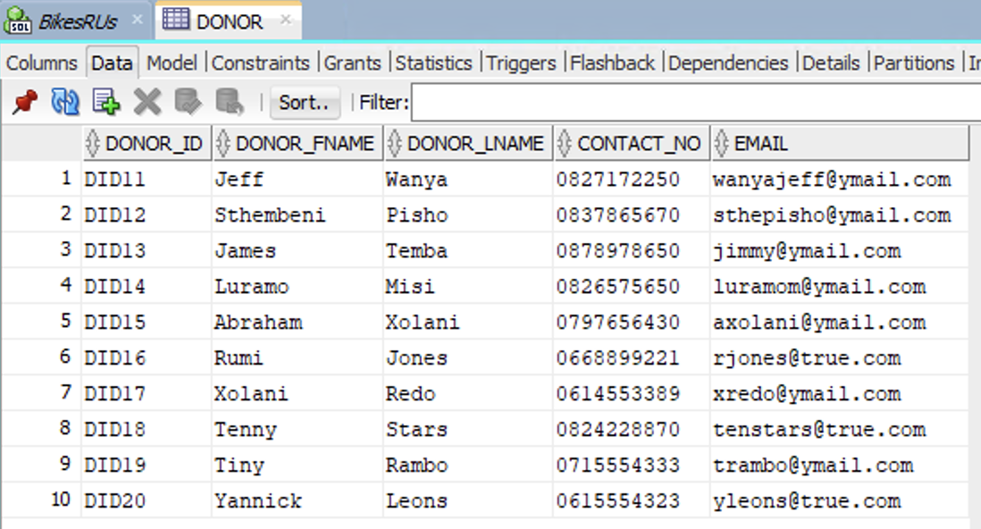

Constraints:

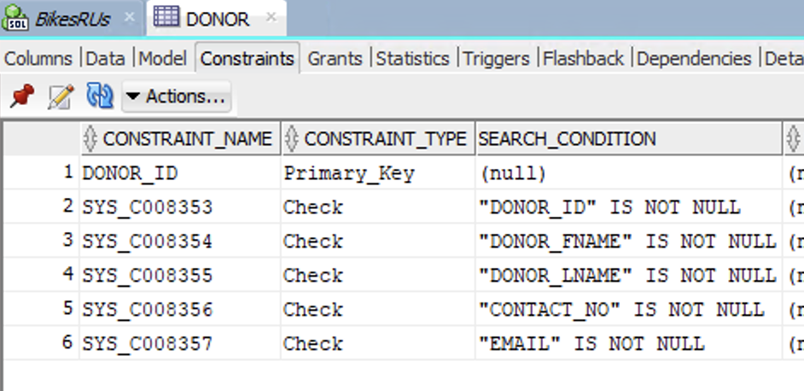

### Bike

Data:

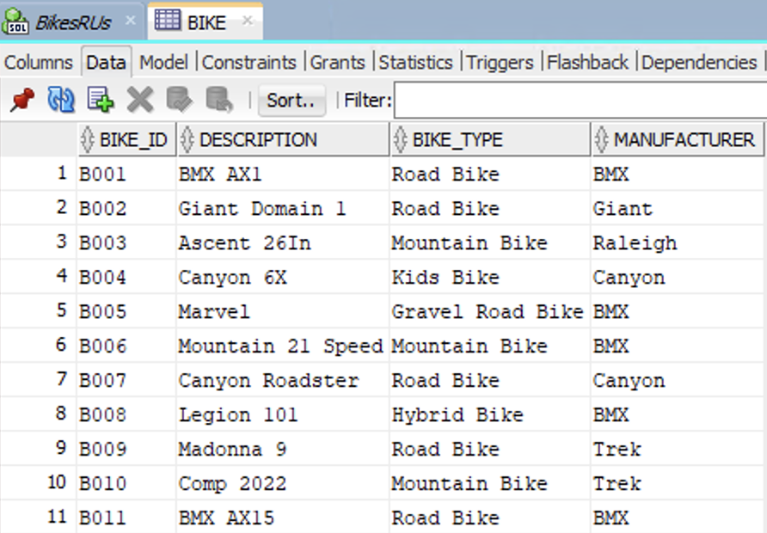

Constraints:

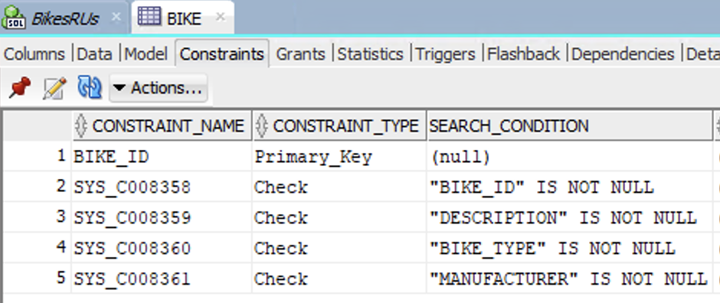

### Donation

Data:

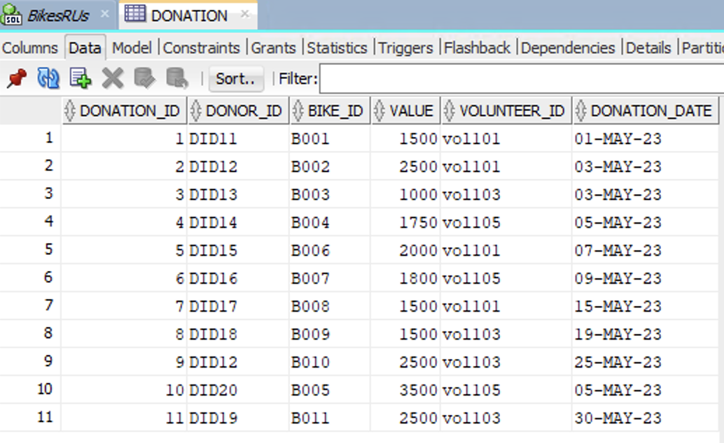

Constraints:

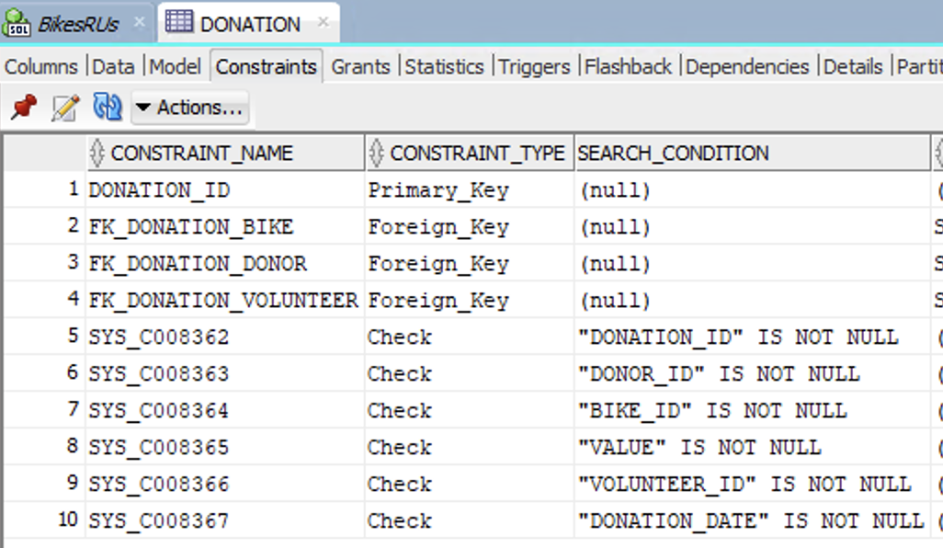

# Question 2

## SQL Code

SELECT

d.DONOR_ID AS "Donor ID",

b.BIKE_TYPE AS "Bike Type",

b.DESCRIPTION AS "Bike Description",

'R ' || d.VALUE AS "Bike Value"

FROM DONATION d

JOIN BIKE b ON b.BIKE_ID = d.BIKE_ID

WHERE d.VALUE > 1500

### Screenshot of Code

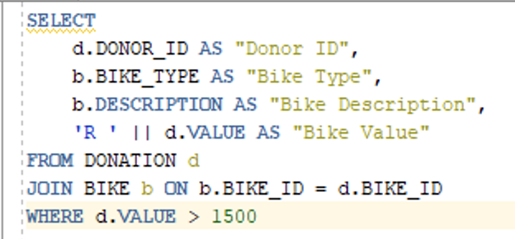

## Screenshot of Successful Output

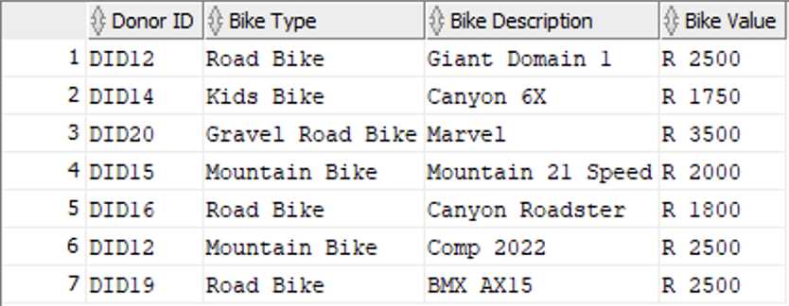

# Question 3

## SQL Code

SET SERVEROUTPUT ON;

DECLARE

c_vat_rate CONSTANT NUMBER := 0.15;

v_vat_amount NUMBER;

v_total_amount NUMBER;

CURSOR curs_roadbikes IS

SELECT

b.DESCRIPTION AS description,

b.MANUFACTURER AS manufacturer,

b.BIKE_TYPE AS type,

d.VALUE AS value

FROM DONATION d

JOIN BIKE b ON b.BIKE_ID = d.BIKE_ID

WHERE b.BIKE_TYPE = 'Road Bike';

BEGIN

DBMS_OUTPUT.PUT_LINE('--- Road Bike VAT Report ---');

DBMS_OUTPUT.PUT_LINE('-------------------------------------------');

FOR r IN curs_roadbikes LOOP

BEGIN

v_vat_amount := r.value * c_vat_rate;

v_total_amount := r.value + v_vat_amount;

-- Display formatted output

DBMS_OUTPUT.PUT_LINE('BIKE DESCRIPTION: ' || r.description);

DBMS_OUTPUT.PUT_LINE('BIKE MANUFACTURER: ' || r.manufacturer);

DBMS_OUTPUT.PUT_LINE('BIKE TYPE: ' || r.type);

DBMS_OUTPUT.PUT_LINE('VALUE: R ' || r.value);

DBMS_OUTPUT.PUT_LINE('VAT: R ' || v_vat_amount);

DBMS_OUTPUT.PUT_LINE('TOTAL AMNT: R ' || v_total_amount);

DBMS_OUTPUT.PUT_LINE('-------------------------------------------');

END;

END LOOP;

END;

/

### Screenshot of SQL Code

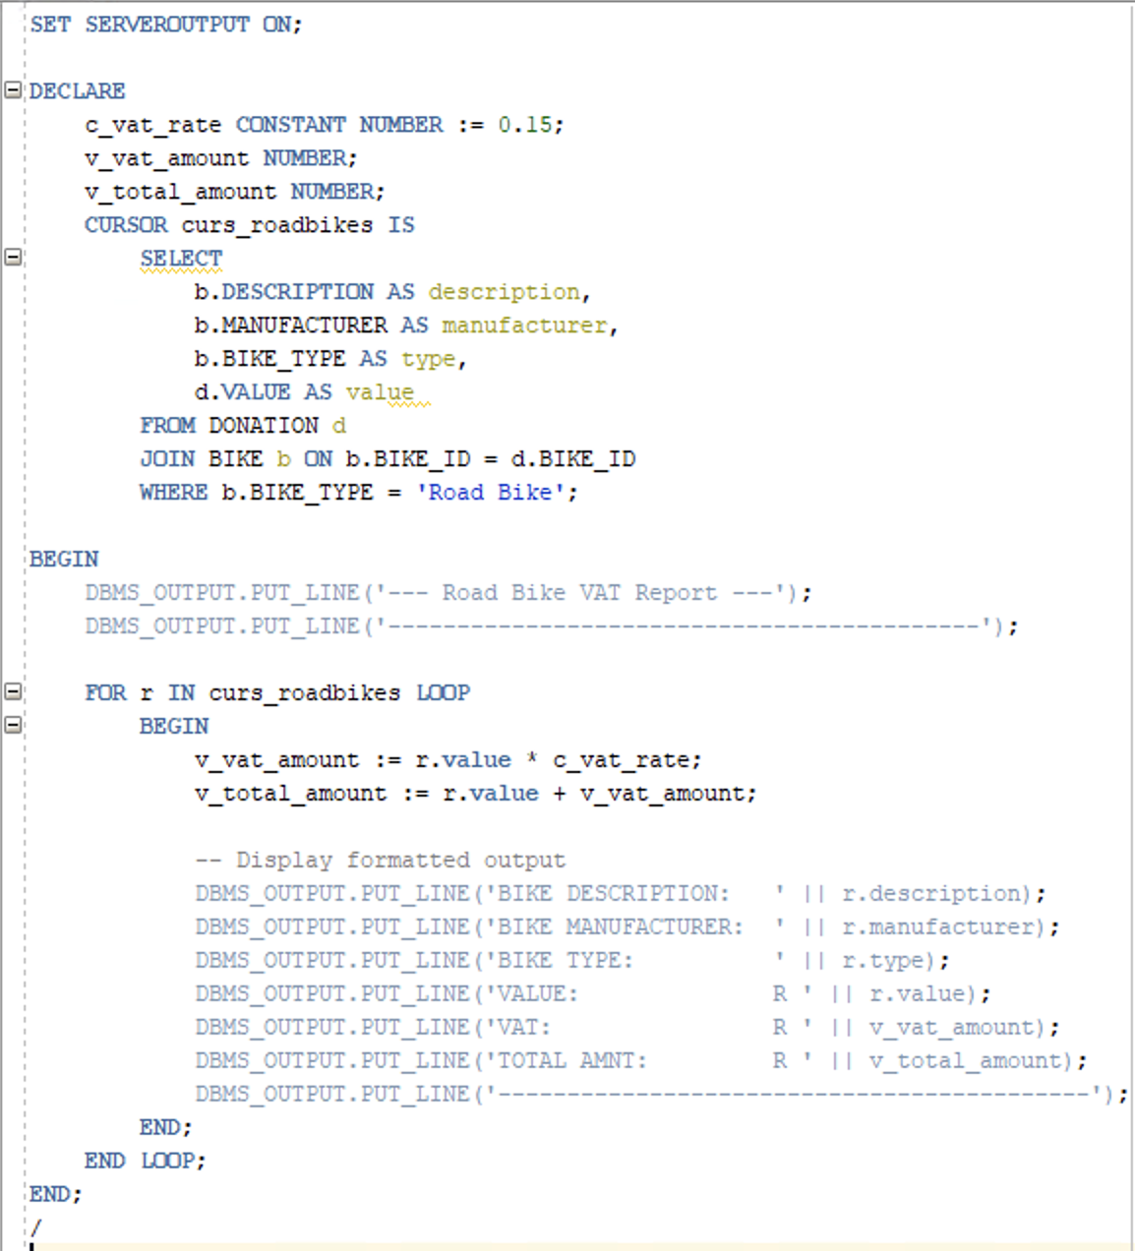

## Screenshot of Successful Output

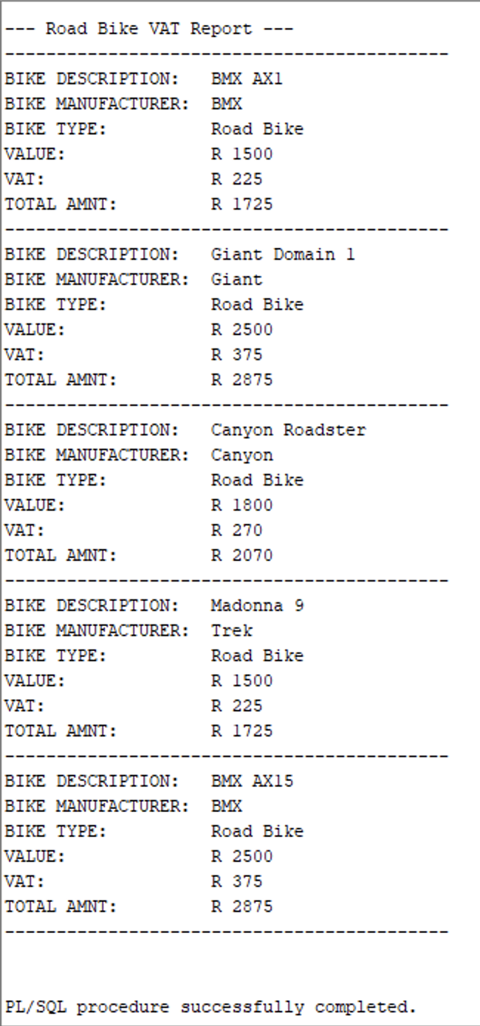

# Question 4

## SQL Code

-- Creating view

CREATE OR REPLACE VIEW vwBikeRUs AS

SELECT

(dn.DONOR_FNAME || ' ' || dn.DONOR_LNAME) AS DONOR_NAME,

dn.CONTACT_NO,

b.BIKE_TYPE,

d.DONATION_DATE

FROM DONATION d

JOIN DONOR dn ON d.DONOR_ID = dn.DONOR_ID

JOIN BIKE b ON d.BIKE_ID = b.BIKE_ID

JOIN VOLUNTEER v ON d.VOLUNTEER_ID = v.VOL_ID

WHERE v.VOL_ID = 'vol105';

SELECT * FROM vwBikeRUs; -- Displaying view

-- Benefits of using a View

/*

1. Simplify complex queries

- Complex joins and conditions are all encapsulated into a single object (GeeksforGeeks, 2025).

- This means that a user can queery the view just like a table.

- This ensures that data is consistent and reusable in a logical capacity.

- This is very beneficial for reports, which BikeRUs will find themselves doing often.

2. Allows data to be presented flexibly

- Views can provide different users with different tailored views (GeeksforGeeks, 2025).

- This can be beneficial as different employees of BikesRUs may be tasked with handling different entities.

- Therefore, each user can have to access to their relevant views and all necessary data.

*/

### Screenshot of SQL Code

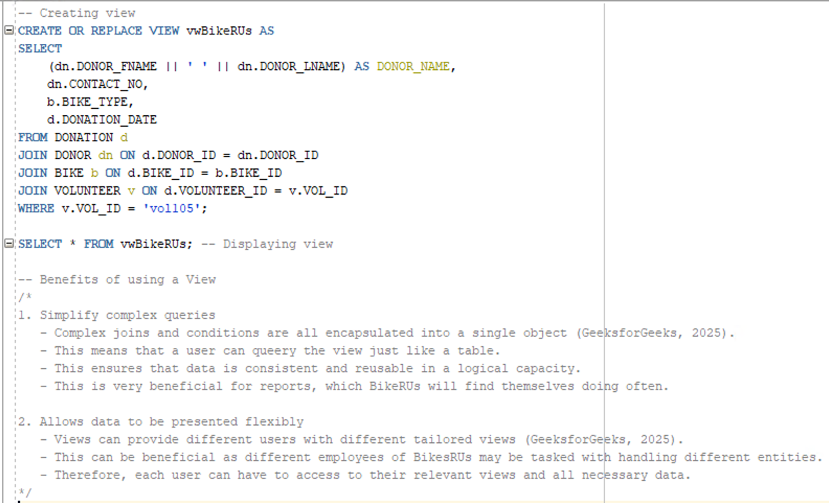

## Screenshot of Successful Output

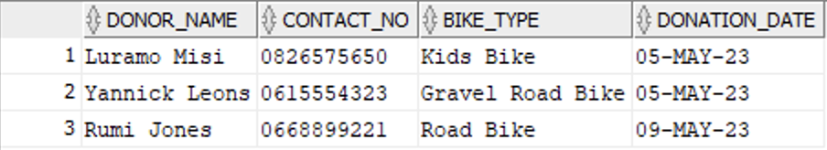

## Reference for Justification

GeeksforGeeks. 2025. SQL Views, 8 September 2025. [Online]. Available at: <https://www.geeksforgeeks.org/sql/sql-views/> [Accessed 10 November 2025].

# Question 5

## SQL Code

SET SERVEROUTPUT ON;

CREATE OR REPLACE PROCEDURE spDonorDetails (p_bike_id IN BIKE.BIKE_ID%TYPE) IS -- takes BIKE_ID as input parameter

-- Declaring variables to store fetched data

v_donor_name VARCHAR2(100);

v_contact_no DONOR.CONTACT_NO%TYPE;

v_vol_first_name VOLUNTEER.VOL_FNAME%TYPE;

v_donation_date DONATION.DONATION_DATE%TYPE;

v_bike_description BIKE.DESCRIPTION%TYPE;

BEGIN

-- Selecting and storing data into variables for given BIKE_ID

SELECT (d.DONOR_FNAME || ' ' || d.DONOR_LNAME), d.CONTACT_NO, v.VOL_FNAME, dn.DONATION_DATE, b.DESCRIPTION

INTO v_donor_name, v_contact_no, v_vol_first_name, v_donation_date, v_bike_description

FROM DONATION dn

JOIN DONOR d ON d.DONOR_ID = dn.DONOR_ID

JOIN VOLUNTEER v ON v.VOL_ID = dn.VOLUNTEER_ID

JOIN BIKE b ON b.BIKE_ID = dn.BIKE_ID

WHERE dn.BIKE_ID = p_bike_id;

DBMS_OUTPUT.PUT_LINE('ATTENTION: ' || v_donor_name || ' assisted by: ' || v_vol_first_name ||

' ,donated the ' || v_bike_description || ' on the ' || v_donation_date);

EXCEPTION

-- Occurs if there is no matching record for given ID.

WHEN NO_DATA_FOUND THEN

DBMS_OUTPUT.PUT_LINE('No donation found for Bike ID: ' || p_bike_id);

-- Occurs when select query returns more than one record.

WHEN TOO_MANY_ROWS THEN

DBMS_OUTPUT.PUT_LINE('Multiple donations found for Bike ID: ' || p_bike_id);

-- Occurs for any other unexpected errors

WHEN OTHERS THEN

DBMS_OUTPUT.PUT_LINE('Unexpected error for Bike ID ' || p_bike_id || ' -> ' || SQLCODE || ': ' || SQLERRM);

END;

/

-- Running procedure for B004

BEGIN

spDonorDetails('B004');

END;

/

### Screenshot of SQL Code

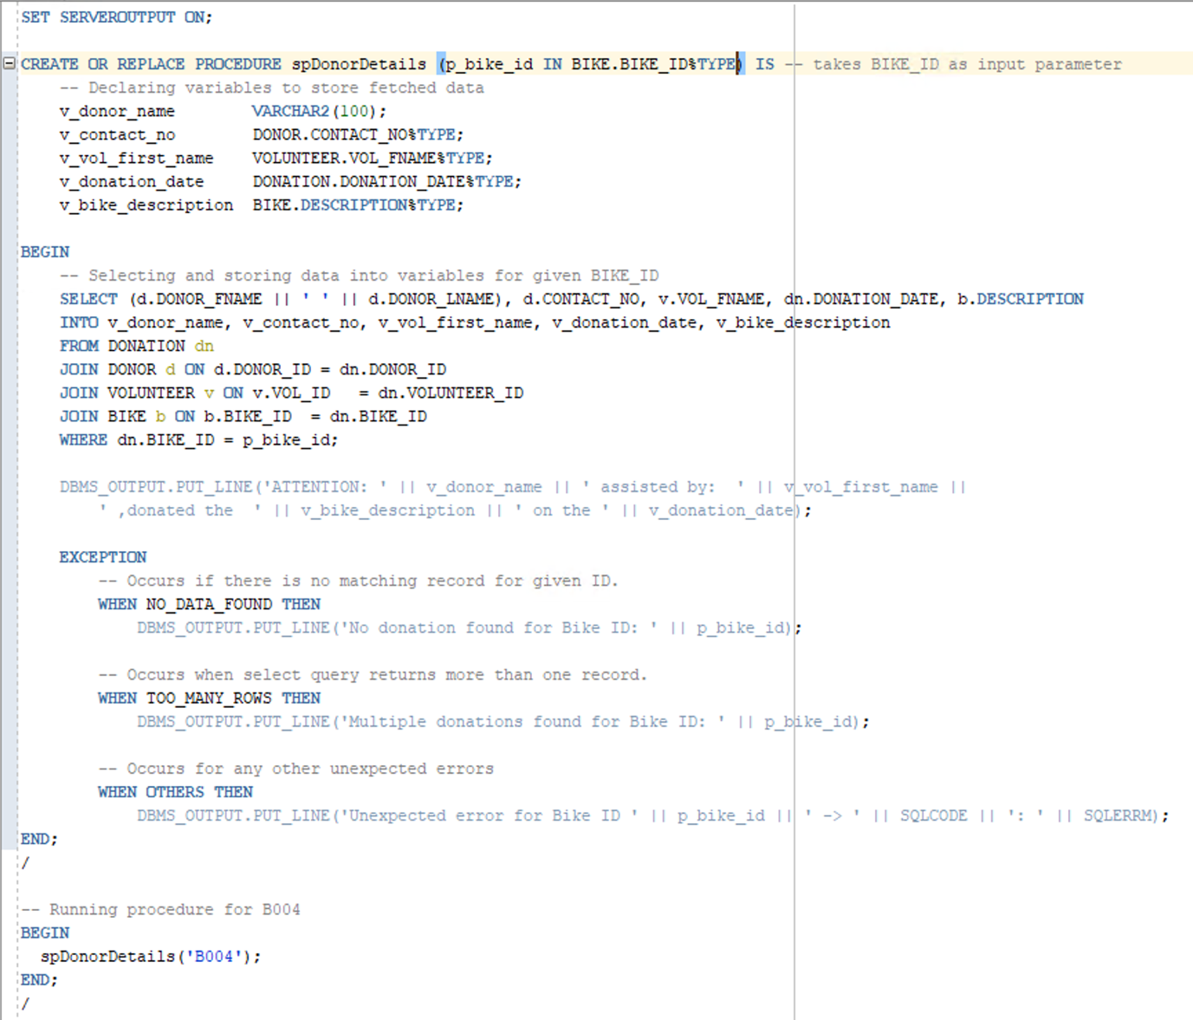

## Screenshot of Successful Output

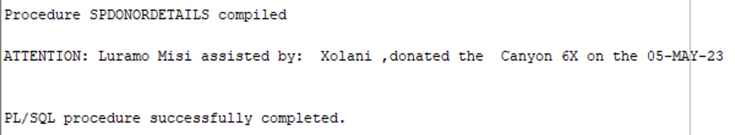

# Question 6

## SQL Code

-- The function will determine the total contribution to donations a specific donor has made.

-- It will take the Donor's ID as an input.

-- Calculations for VAT are included, as well as a sum of donations.

-- The function will return a number for the total sum.

SET SERVEROUTPUT ON;

CREATE OR REPLACE FUNCTION fnDonorContribution(p_donor_id IN DONOR.DONOR_ID%TYPE) RETURN NUMBER IS -- input parameter

-- Declaring variables to store fetched data and calculations

v_donor_name VARCHAR2(100);

v_contact_no DONOR.CONTACT_NO%TYPE;

v_total_donations NUMBER;

c_vat_rate CONSTANT NUMBER := 0.15;

BEGIN

-- Selecting Donor's details for given donor

SELECT (dr.DONOR_FNAME || ' ' || dr.DONOR_LNAME), dr.CONTACT_NO

INTO v_donor_name, v_contact_no

FROM DONOR dr

WHERE dr.DONOR_ID = p_donor_id;

-- Selecting and totalling all donations made by donor

SELECT SUM(dn.VALUE)

INTO v_total_donations

FROM DONATION dn

WHERE dn.DONOR_ID = p_donor_id;

-- Informs the user if the donor exists but has no donations

IF v_total_donations IS NULL THEN

DBMS_OUTPUT.PUT_LINE('No donations for Donor ID: ' || p_donor_id);

END IF;

-- Output results to user

DBMS_OUTPUT.PUT_LINE('--- Donor Contribution Summary ---');

DBMS_OUTPUT.PUT_LINE('Donor: ' || v_donor_name);

DBMS_OUTPUT.PUT_LINE('Contact: ' || v_contact_no);

DBMS_OUTPUT.PUT_LINE('Total (ex VAT): R ' || v_total_donations);

DBMS_OUTPUT.PUT_LINE('VAT @ 15%: R ' || v_total_donations*c_vat_rate);

DBMS_OUTPUT.PUT_LINE('Total (incl VAT): R ' || v_total_donations*(1+c_vat_rate));

DBMS_OUTPUT.PUT_LINE('----------------------------------');

-- Return total donations inclusive of VAT

RETURN v_total_donations*(1 + c_vat_rate);

EXCEPTION

WHEN NO_DATA_FOUND THEN

-- Triggered if the donor id does not exist

DBMS_OUTPUT.PUT_LINE('Error: Donor ID ' || p_donor_id || ' not found.');

RETURN NULL;

WHEN OTHERS THEN

-- If any other errors occur

DBMS_OUTPUT.PUT_LINE('Unexpected error in fnDonorContribution: ' || SQLERRM);

RETURN NULL;

END fnDonorContribution;

/

-- Executing the function

DECLARE

-- Declaring the variable to fetch and store value

v_total_incl_vat NUMBER;

BEGIN

-- Running function and storing return value

v_total_incl_vat := fnDonorContribution('DID12');

-- Checks if donor has donations

IF v_total_incl_vat IS NOT NULL THEN

DBMS_OUTPUT.PUT_LINE('Function return value (incl VAT): R ' || v_total_incl_vat);

END IF;

EXCEPTION

WHEN OTHERS THEN

-- Catching any error

DBMS_OUTPUT.PUT_LINE('Error caught: ' || SQLERRM);

END;

/

### Screenshot of SQL Code

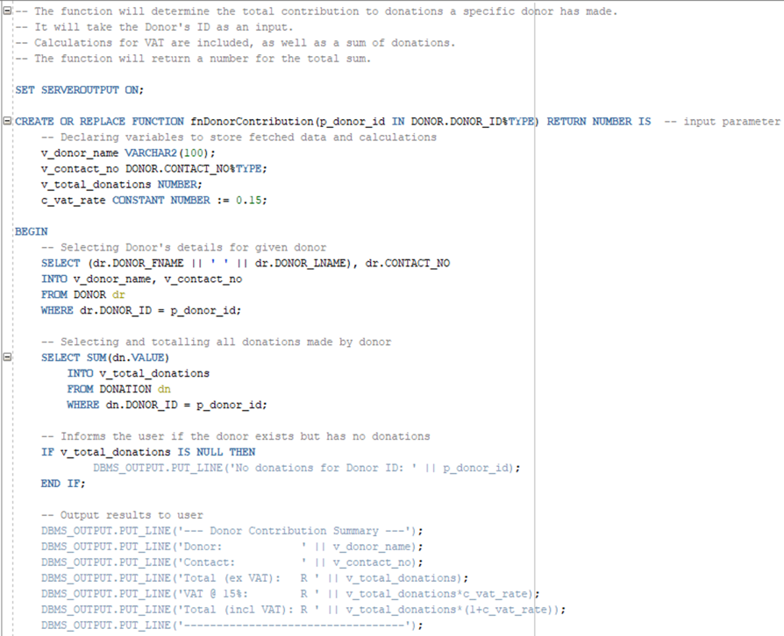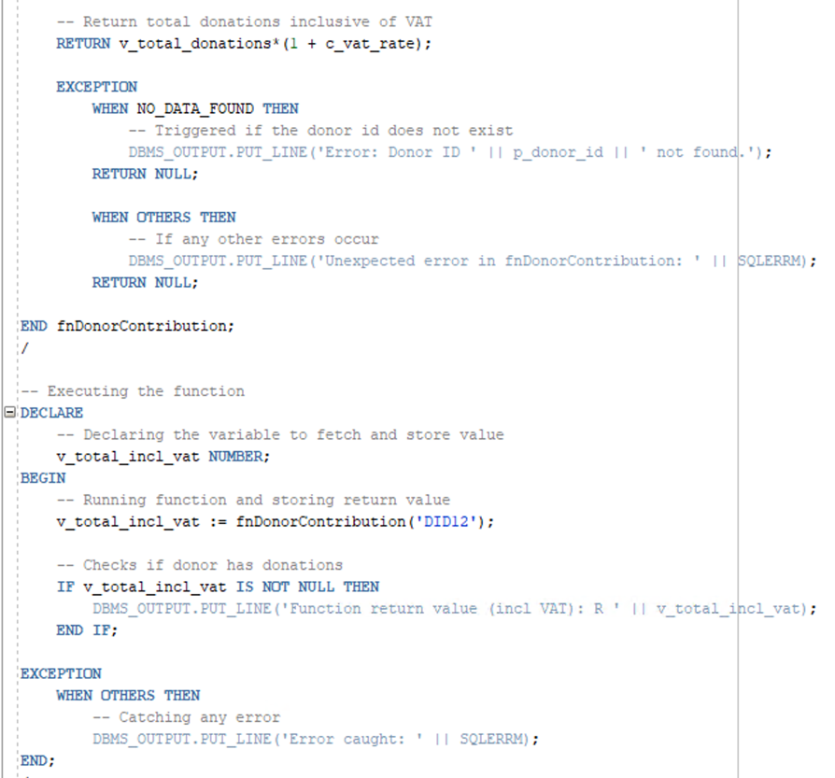

## Screenshot of Successful Output

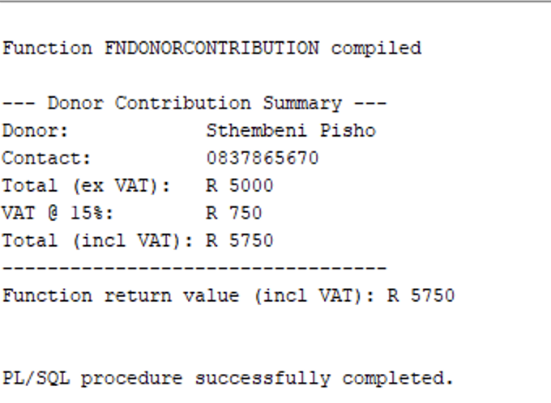

# Question 7

## SQL Code

SET SERVEROUTPUT ON;

DECLARE

v_bike_id BIKE.BIKE_ID%TYPE;

v_bike_type BIKE.BIKE_TYPE%TYPE;

v_manufacturer BIKE.MANUFACTURER%TYPE;

v_value DONATION.VALUE%TYPE;

v_status VARCHAR2(10);

CURSOR cur_bike_status IS

SELECT b.BIKE_ID, b.BIKE_TYPE, b.MANUFACTURER, d.VALUE

FROM BIKE b

JOIN DONATION d ON b.BIKE_ID = d.BIKE_ID

ORDER BY b.BIKE_ID;

BEGIN

DBMS_OUTPUT.PUT_LINE('--- BikeRUs Bike Status Report ---');

DBMS_OUTPUT.PUT_LINE('-------------------------------------------');

FOR r IN cur_bike_status LOOP

v_bike_id := r.BIKE_ID;

v_bike_type := r.BIKE_TYPE;

v_manufacturer := r.MANUFACTURER;

v_value := r.VALUE;

IF v_value <= 1500 THEN

v_status := '*';

ELSIF v_value > 1500 AND v_value <= 3000 THEN

v_status := '**';

ELSE

v_status := '***';

END IF;

DBMS_OUTPUT.PUT_LINE('BIKE ID: ' || v_bike_id);

DBMS_OUTPUT.PUT_LINE('BIKE TYPE: ' || v_bike_type);

DBMS_OUTPUT.PUT_LINE('BIKE MANUFACTURER: ' || v_manufacturer);

DBMS_OUTPUT.PUT_LINE('BIKE VALUE: ' || v_value);

DBMS_OUTPUT.PUT_LINE('STATUS: ' || v_status);

DBMS_OUTPUT.PUT_LINE('-------------------------------------------');

END LOOP;

EXCEPTION

WHEN OTHERS THEN

DBMS_OUTPUT.PUT_LINE('An unexpected error occurred: ' || SQLERRM);

END;

/

### Screenshot of SQL Code

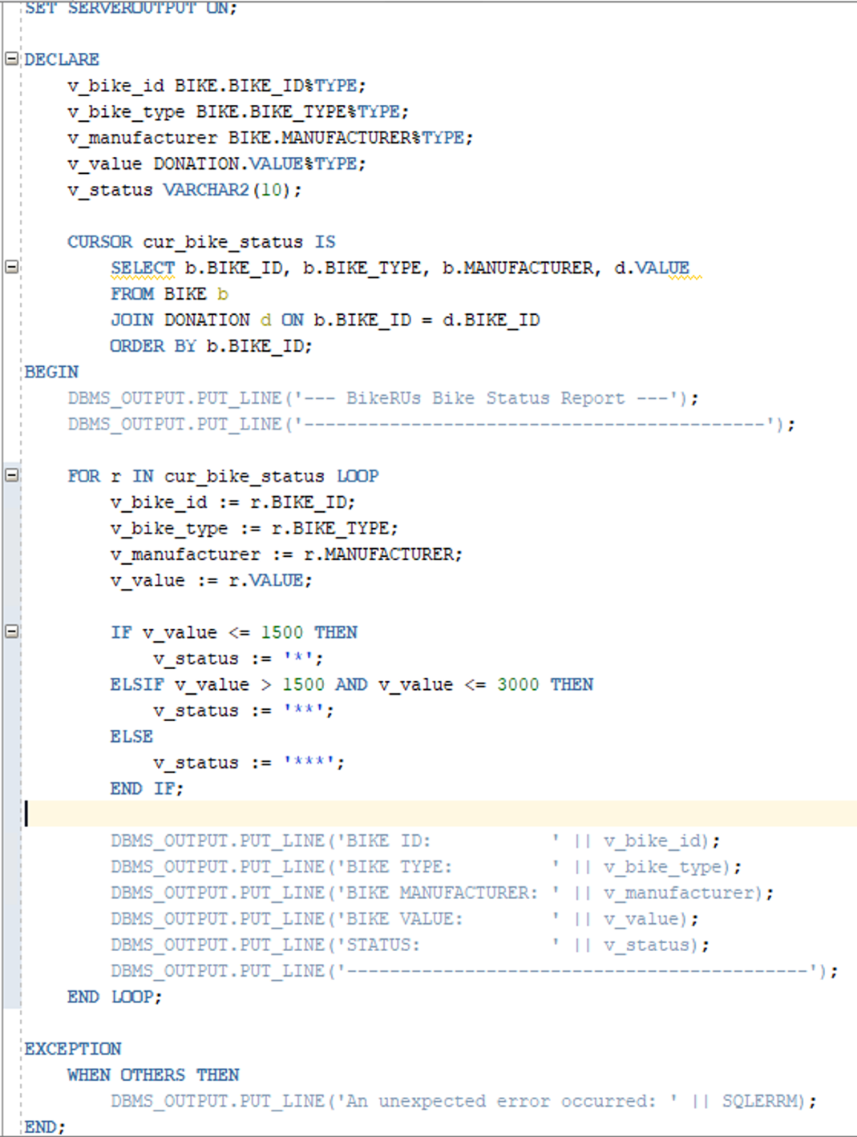

## Screenshot of Successful Output

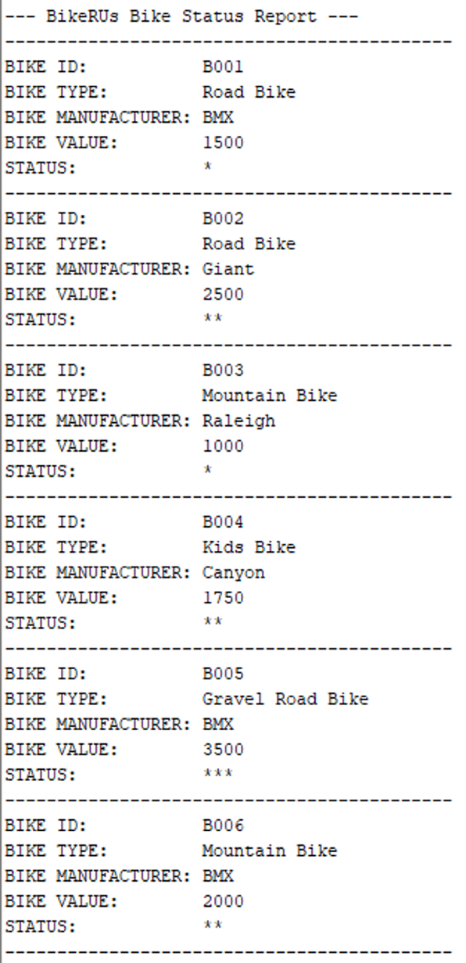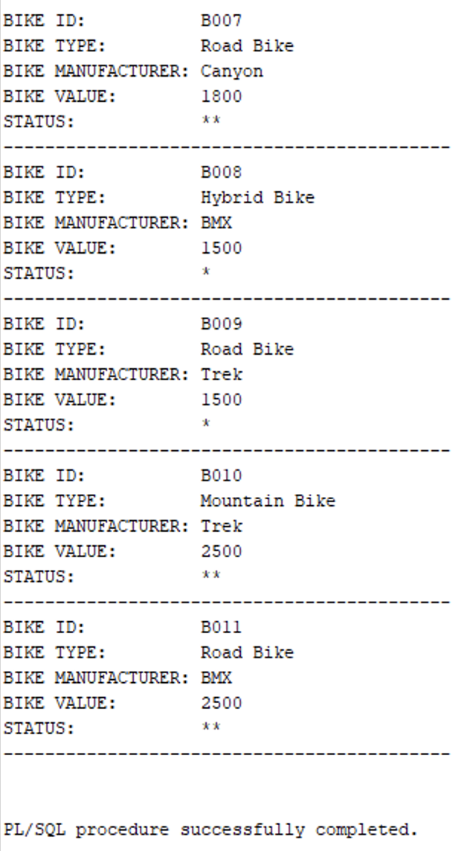

# Question 8

## SQL Code

SELECT

b.BIKE_ID,

b.BIKE_TYPE,

b.MANUFACTURER,

d.VALUE,

CASE

WHEN d.VALUE <= 1500 THEN '*'

WHEN d.VALUE > 1500 AND d.VALUE <= 3000 THEN '**'

WHEN d.VALUE > 3000 THEN '***'

ELSE 'N/A'

END AS "STATUS"

FROM BIKE b

JOIN DONATION d ON b.BIKE_ID = d.BIKE_ID

ORDER BY b.BIKE_ID;

### Screenshot of SQL Code

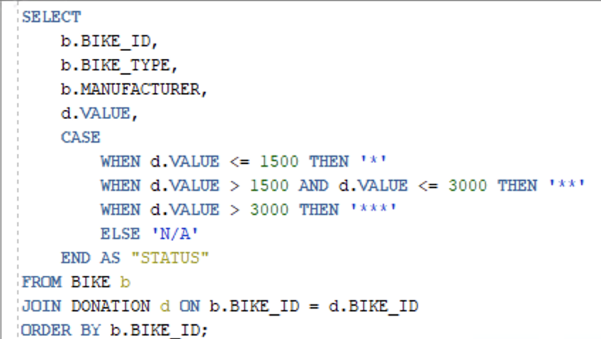

## Screenshot of Successful Output

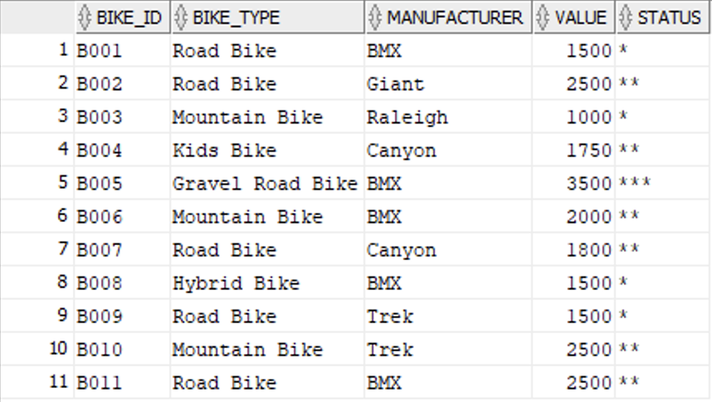

# Question 9

## Q9.1: Donation Delete Trigger

### SQL Code

-- Trigger Creation: Prevent deletion from DONATION table

CREATE OR REPLACE TRIGGER trg_prevent_donation_delete

BEFORE DELETE ON DONATION

FOR EACH ROW

BEGIN

RAISE_APPLICATION_ERROR(

-20010,

'ERROR: Deletion from the DONATION table is not permitted by BikeRUs policy.'

);

END;

/

-- Testing trigger

DELETE FROM DONATION WHERE DONATION_ID = 1;

#### Screenshot of SQL Code

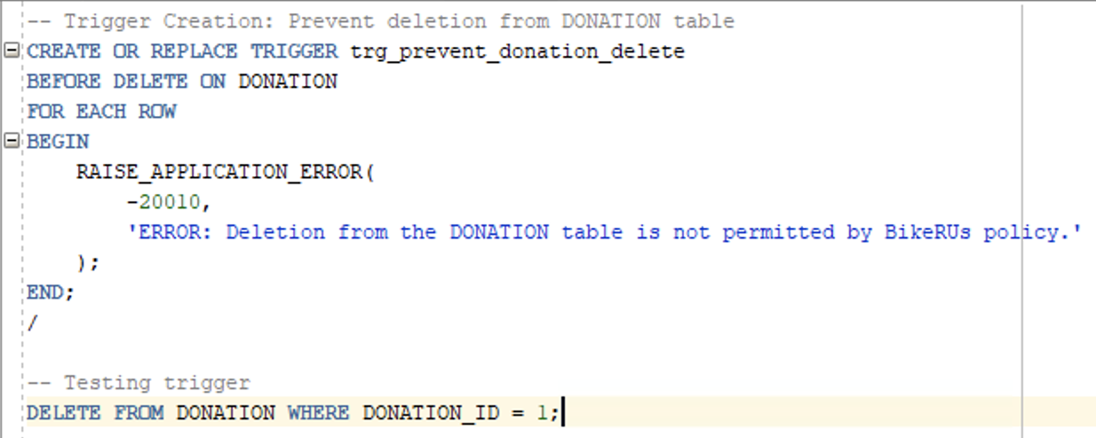

### Screenshot of Successful Output and Trigger Occurring



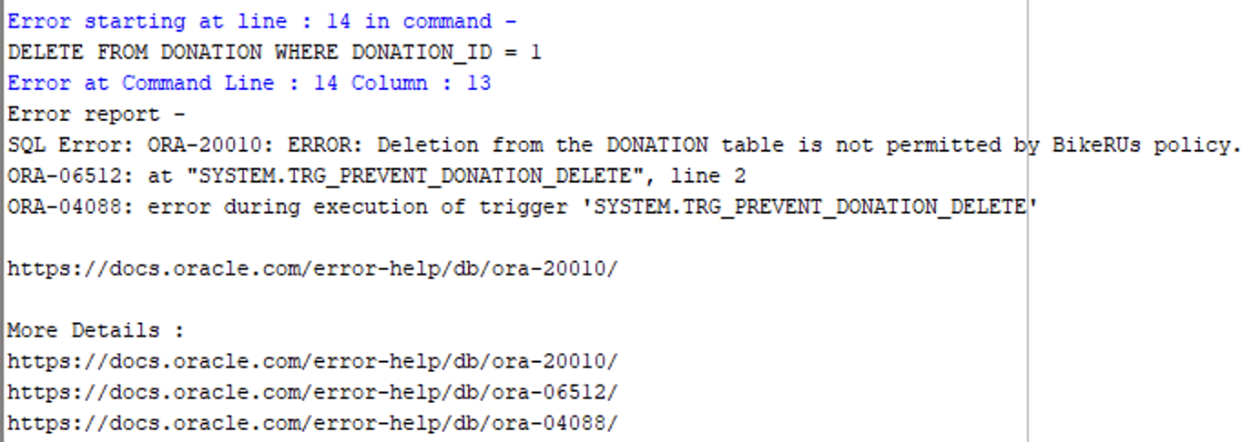

## Q9.2: Bike Validation Trigger

### SQL Code

-- Trigger Creation: Prevent invalid (≤ 0) bike values on update

CREATE OR REPLACE TRIGGER trg_validate_bike_value

BEFORE UPDATE OF VALUE ON DONATION

FOR EACH ROW

BEGIN

IF :NEW.VALUE <= 0 THEN

RAISE_APPLICATION_ERROR(

-20020,

'ERROR: Invalid donation value entered. Bike value must be greater than 0.'

);

END IF;

END;

/

-- Testing trigger

UPDATE DONATION

SET VALUE = 0

WHERE DONATION_ID = 1;

#### Screenshot of SQL Code

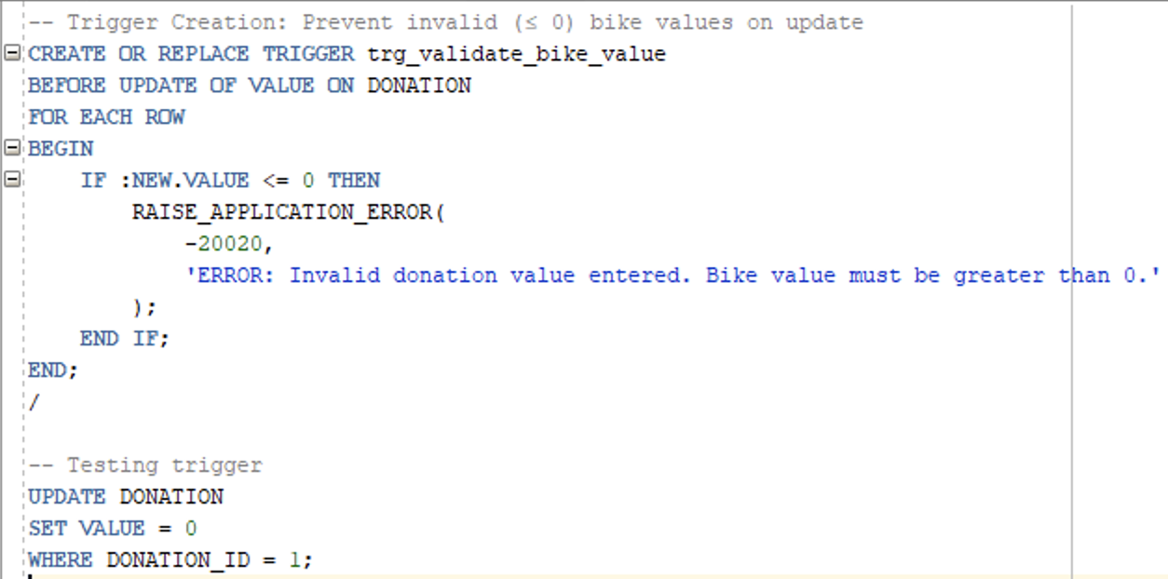

### Screenshot of Successful Output and Trigger Occurring

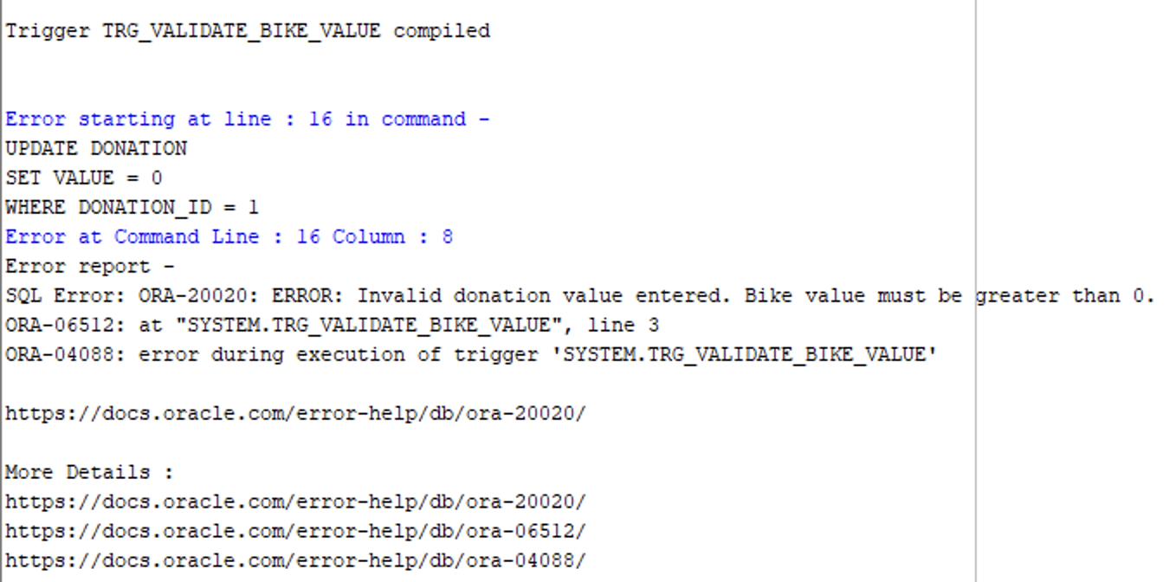

# Question 10

## Introduction

BikesRUs have experienced massive growth recently. This has resulted in more sensitive data being collected by the business. It is thus essential to introduce features so trust with customers is maintained and the business can operate within regulations. This report will outline how confidentiality and integrity of data will be implemented using technical strategies and tools. Confidentiality involves that sensitive information (such as contact numbers, emails, etc.) is only accessible to individuals that have authorisation. Integrity involves ensuring that data stored in the system is accurate and consistent. This report will mention how certain tools and techniques can help implement these aspects into the system to maintain data security.

## Confidentiality

Confidentiality involves ensuring that only authorised individuals and users have access to the data. In regards to BikesRUs, this would involve ensuring that Volunteer and Donor details, such as contact number and email, are kept disclosed. Therefore, introducing encryption, access control and other measures will help enforce confidentiality.

### Role-Based Access Control

Oracle (2025) mentions that one way to do this is to use Oracle Role-Based Access Control. This involves granting certain permissions to different levels of authority in the business. Example:

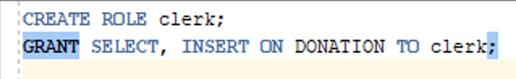

This would mean that clerks in the business can only select and insert data for the Donation table. Giving clerks these permissions means that they can’t delete or update data. This helps ensure confidentiality is maintained.

### Data Encryption

Oracle (2025) mentions that another method is to implement transparent data encryption. This is done using advanced encryption standard so that viewed data is encrypted (Oracle, 2025). Example:



This ensures that the contact number of Donors are encrypted and unreadable. Furthermore, Donor contact numbers are also unreadable if the physical database files are accessed illegally (Oracle, 2025).

## Integrity

Integrity is the principle that data is accurate and consistent throughout the system, ensuring that unauthorised data manipulation does not occur. For BikesRUs, this would mean that, without authorisation, donations cannot be deleted, altered, or incorrectly linked to Donor, Volunteer, or Bikes through foreign keys.

### Database Constraints

One method to implement integrity to data is to add constraints to data variables. Including constraints on data helps ensure that only correct data values are inserted and kept in tables. Example:

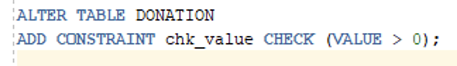

This constraint on Value will ensure that only positive values for donations are entered. This further ensures that no incorrect values for value occur, enhancing data integrity for the BikesRUs system.

### Audit Trails

Oracle (2025) mentions that introducing audit trails is an excellent way to enhance integrity. Audit trails will keep track of any changes that occur in the database (Oracle, 2025). Example:



This will produce a record in the audit log of every transaction that occurs for the Donation table on the database. This helps implement complete transparency as it provides documentation of all changes, further enforcing integrity.

## Conclusion

Confidentiality and integrity of data is a necessary implementation for BikesRUs. To ensure this is introduced, a combination of technical and human controls are essential. BikesRUs can implement confidentiality through access control and encryption, and can implement integrity through constraints and audit trails. Implementing these measures in tandem would allow BikesRUs’ data to remain accurate and secure. This will help ensure that the business’ reputation is upheld as they continue to grow.

# References

Oracle. 2025. Audit Trails. [Online]. Available at: <https://docs.oracle.com/en/cloud/paas/data-safe/udscs/audit-trails.html> [Accessed 10 November 2025].

Oracle. 2025. Introduction to Transparent Data Encryption. [Online]. Available at: <https://docs.oracle.com/en/database/oracle/oracle-database/26/dbtde/introduction-to-transparent-data-encryption.html> [Accessed 10 November 2025].

Oracle. 2025. CREATE ROLE. [Online]. Available at: <https://docs.oracle.com/en/database/oracle/oracle-database/19/sqlrf/CREATE-ROLE.html> [Accessed 10 November 2025].